Ref: IBA/JCa
Wednesday 3rd December 2025

Dear parents/guardians

Invitation to an evening of music: The National Church of England Academy Christmas Concert

The festive season is nearly upon us and we are writing to invite you and your family to an evening of musical entertainment, provided by our very own students at the National Church of England Academy.

The evening will showcase our students’ talents and achievements and entertain you with a selection of musical acts and some of your festive favourites.

The evening will take place on Monday 15th December 2025, starting at 6:00pm (doors open at 5:45pm) at St Mary Magdalene Church, Hucknall marketplace. We will be taking donations in lieu of ticket costs, should you wish to donate on the evening you will be able to do so.

Please fill out the form below with the number of seats you would like reserving for the concert by Friday 12th December. We need to use a reservation system to ensure we have enough seats for everyone in the church and we do not exceed our maximum capacity. Priority will be given to those families who have students performing in the concert.

We look forward to celebrating with you.

Yours sincerely,
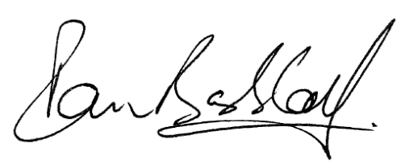


Mr I Baggott Mrs K Wall
Teacher of music Assistant Headteacher

Invitation to an evening of music: The National Church of England Academy Christmas Concert

Please complete the form by Friday 12th December.

Name of student: _________________________________________________

I will be attending the Christmas Concert on Monday 15th December, starting at 6:00pm.

Number of seats required: _______

Signed_____________________________________________________________
(Parent/guardian)

